Part A: Recapped on how to use print() and input() statements in Python

1. Print “Hello”
2. Write a program to get an input word from a user. Then, display the given word together with the sentence of “Welcome, ” as below:

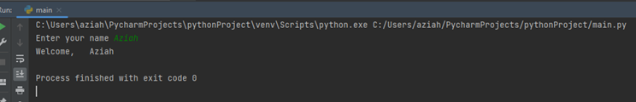

1. Write a program to get two inputs from user. Then display the input.

**Output sample:**

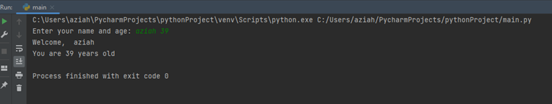

Part B: Test Yourself

Instructions:

* You are to code the following programs in the lab and show the output to your lecturer.
* Write comments to make your programs readable.
* Use descriptive variables in your program (Name of the variables should show their purposes)

1. Accept number from user and display it.
2. Accept 2 numbers from user and display addition of it.
3. Accept 2 input values from user and do arithmetic operation. (+, -, *, /, %).
4. Accept 2 numbers from user and print swapping of those number.
5. Write a pseudocode and a python code to accept 5 subject marks from student and calculate the total and percentage(average) of a student for a semester and display it.
6. Write a pseudocode and python code to accept Basic from an employee and calculate salary of an employee by considering following things. (Grade_pay is double of Basic. DA is 70% of Basic. TA is RM 200. HRA is 20% of Basic.)(Formula for salary = Grade_pay + DA + TA + HRA).